**EXPERIMENT 9 - VIEWS**

**use db;**

**create table Product(PID int, Pname varchar(10), cid int, price int);**

**insert into Product values(1,"chais",1,18);**

**insert into Product values(2,"chang",1,19);**

**insert into Product values(3,"ikura",2,6);**

**insert into Product values(4,"tofu",7,25);**

**insert into Product values(5,"pavlova",3,30);**

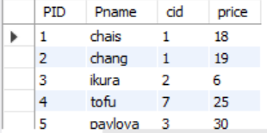

**create view ProductAboveAveragePrice as**

**select Pname, price from Product**

**where price > (select AVG(price) from Product);**

**select * from ProductAboveAveragePrice;**

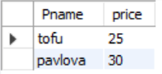

**Show create view ProductAboveAveragePrice;**



**drop view ProductAboveAveragePrice;**